**ASSIGNMENT 3 – QUERY RESULTS**

**MD Kamruzzaman Kamrul**

**TASK 1. MONGODB CRUD**  
  
**1.1 Get number of successful projects in “Video Games” category (state is “successful”).**

**Output:** 344

**1.2 Get the total number of projects in “Video Games” or “Playing Cards” categories.**

**Output:** 1711

**1.3 Blockbuster projects are those with extremely high pledged amount and backer count. Find the number of blockbuster projects in the data by querying projects with pledged >=$1,000,000 and backers >=10,000.**

**Output:** 25

**1.4 Find the top three pledged projects in “Video Games” category; display the output with “_id” and pledged only.**

**Output:**

**1.5 Update the collection “projects” with a new field “success”; this new field equals to 1, if  
state is “successful”, and 0, otherwise.**

**Output:**

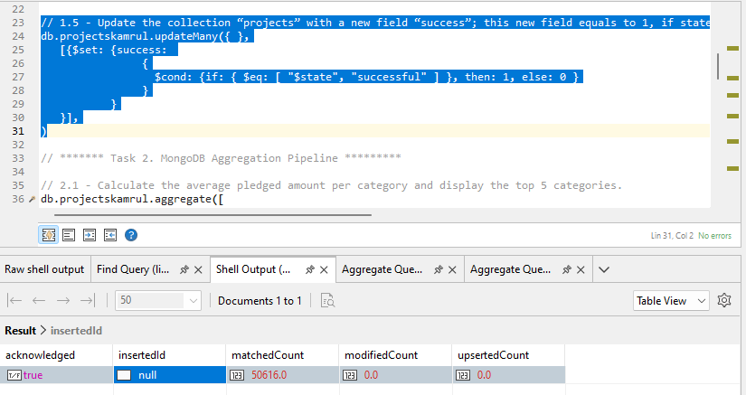

**TASK 2. MONGODB AGGREGATION PIPELINE**

**2.1 Get the average pledged amount by project category. Sort your output descending by  
average pledged amount and limit your output to the first five documents.**

**Output:**

**2.2 Get the success rate by project category (Hint: use $divide in $project). Limit your output  
to the first five documents.**

**Output:**

**2.3 Get the number of projects by each state in the US. Sort the output descending by number of projects and limit your output to the first five documents.**

**Output:**

**2.4 Get the success rate of each state in the US. Limit your output to the first five documents.**

**Output:**

**2.5 Sample 10,000 projects, then obtain the creators (creator ID) with at least 3 successful  
projects.**

**Output:**

